Amy Priddy
NECP
Room 204
Email:amy.priddy@rcsdk12.org
Phone: 324-3279 ext: 2040

English II

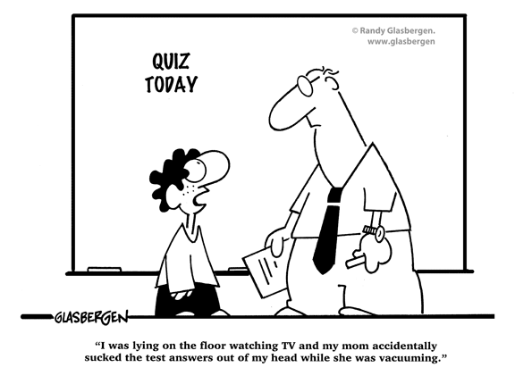

Course Overview

English II is a course designed to further your critical exploration into language by following the theme of “identity.” Learners will be exposed to regular and varied opportunities to read, write, speak and listen. English students will prepare for the NYS English Regents Exam at the end of their junior year according to NYS Standards:

#1 language for information and understanding
#2 language for literacy response and expression
#3langauge for critical analysis and evaluation
#4 language for social interaction

Expectations:

BE PREPARED: Come to class every single day. This means the basics: pens, pencil, plenty of paper. It makes everyone’s life a lot easier if you are prepared for the work.

CARE: The best way to engage in a great classroom discussion is if everyone feels that their viewpoint is valid and respected. It goes without saying that you will respect your classmates, yourself and adults in the room. Don’t settle for anything less than your best.

BE ON TIME: There’s nothing more annoying than starting and stopping a lesson because of tardiness or lateness. Be on time, it’s that simple. You would be on time for a job, right?

NO TOYS: Please put away all of your toys (cell phones, mp3 players…) keep them out of sight. I promise you won’t miss them that much.

Course Content:

WRITING: Be prepared to write. We will learn and master the critical lens essay, the controlling idea essay, as well as others. We will also be writing response entries, ticket-out-the-door and warm up entries, as well as creative writing.

READING: You will be reading a variety of genres such as novels, poetry, short stories, essays, newspapers, cartoons, etc and learn to successfully analyze these texts.

LISTENING: You will use your ear as a tool in class for discussion, readings, movies, etc.

SPEAKING: You will be thinking ad speaking critically in class in a variety of ways such as Socratic Seminar, group work, etc.

Materials Needed For TUESDAY!!!

- Plenty of pens, pencils, paper.
- Source Book (one of those black and white marble ones)
- A binder for your work

Extra Help/Parent Contact

I’m always around for extra help. See my contact info on the first page for specifics and meet with me to set up a time that works the best.

Course Grading:

- Tests/Essays: 65%
- Classwork: 15%
- Homework: 10%
- Daily Participation: 10%

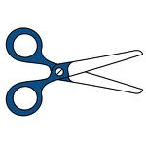______________________________________________________________

Please Detach, sign and return by Tuesday September 7th:

I have read and understood this course information sheet.

Student:_______________________________________________________

Parent/Guardian: ___________________________________________________

